TWO BRIDGES (and a culvert) OF CHATHAM COUNTY
Bill Sharpe
US 15-501 from Chapel Hill to the outskirts of Pittsboro is now a boulevard with increasing traffic and a growing number of stoplights. It was quite different 100 years ago
A 1920 AAA map shows the segment from Chapel Hill to Bynum as ‘a gravel dirt road’. Riggsbee was a small community located at what is now the intersection of 15-501 and Briar Chapel Parkway. The segment from Bynum to Pittsboro was ‘hard surface’, probably because the managers of the cotton mill in Bynum lived in Pittsboro. An earlier 1910 map (2) shows the entire road as ‘scraped into shape’. The road was paved in 1927 (3), and listed as State Highway 75 on a 1930 Chatham County roadmap (4). It remained essentially unchanged until ~1960 when the first lane of the boulevard bypassed Bynum. It was a narrow two-lane road; the current last mile into Pittsboro is basically unchanged.
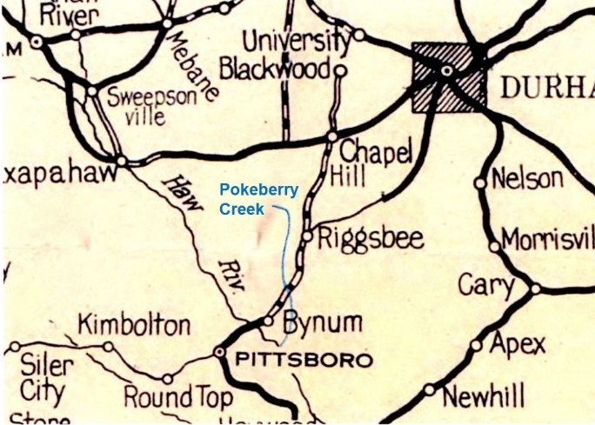
1920 AAA map with Pokeberry Creek added (1)

Early travel between the two towns was impeded by the Haw River and Pokeberry Creek. That was not unwelcome in one case. “In January, 1865, a heavy freshet swept away every bridge on Haw’s River, which at the time was considered a great calamity, but resulted in being a blessing, for in April the plundering bands of bummers from the Federal Army were prevented from crossing the river, and much property thus saved.” That order was not always obeyed. One soldier crossed the river and stole a horse. The owner, “….shot him off his horse and buried him. He was a Yankee soldier stealing his horse, and he got his horse back. Said all he had to do was whistle. But life was pretty cheap if you was a Yankee come along then coming around in here. ” (5)
HAW RIVER BRIDGE
The town of Bynum is on property between the Haw and Pokeberry purchased in the late 1770s by Luke Bynum (6). His descendent, Carney Bynum, built a long wooden covered bridge across the Haw after the 1865 storm. He sold it to the County for $5.00 in 1867 (7), but continued to maintain it, charging the county $108.90 in 1878 (8). But, in 1879, the County Commissioners voted to build a new covered bridge at Bynum instead of repairing the old one – not to exceed $5000 in cost. (9)
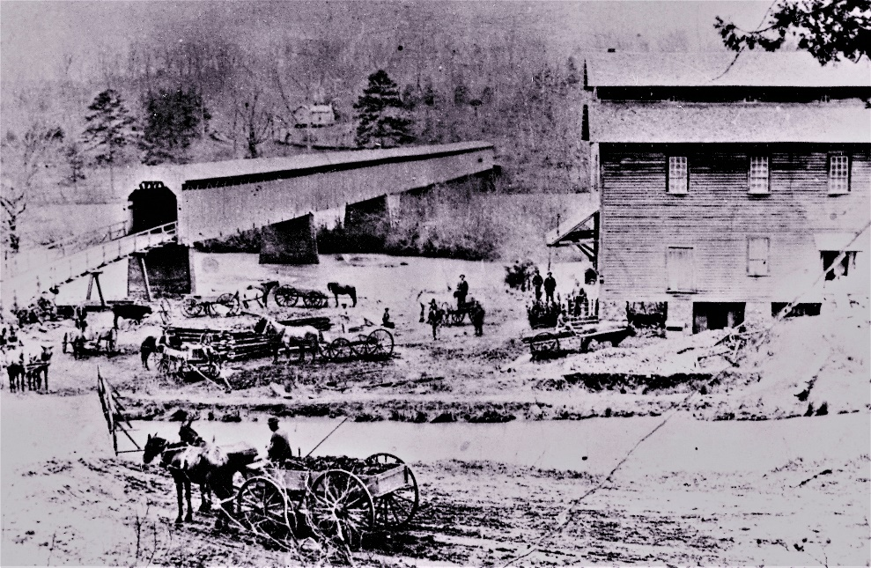
Wooden bridge at Bynum circa 1900. (10)

The bridge was covered to protect the wood trusses from the weather and the built high above the river to avoid a repeat of the 1865 disaster. That was easy on the hilly south side, but required a precarious looking ramp from the flatland on the north side. Farmers brought corn and wheat to the large grist mill; a cotton mill was added to it in 1872. (11)
It was a one-lane bridge, so whoever got on it first had the right-of-way. That was not always observed, “One day when this old man, Mr. Crutchfield, was on the bridge, and this other fellow saw that he whas already on the bridge, and he was in a smart buggy and horse, and he started on it, told Mr. Crutchfield to get off. Mr. Crutchfield said he wouldn’t have no idea of getting off, so he got out of his wagon, had this big leather strap in his hand, he told that man if he didn’t get off that bridge right away, he would whip him off. So he backed out pretty quickly.” (5). Louise Moore, my wife’s aunt, was born in 1911 and recalled crossing the bridge. Both she and the horse were scared. Her father blindfolded the horse and led him to the other side. She was scared because it was noisy inside from the steel rims on the wagon wheels as they crossed small gaps in the wooden floor. Early automobiles used the bridge as well. A model T Ford weighed 1200 pounds, considerably less than the two horses and wagon in the picture.
Amazingly, that bridge lasted until 1922 when it was replaced by an 800 foot long concrete bridge. Bynum was bypassed in ~1960 when a new bridge was built upstream. The bridge was closed to vehicular traffic in 1999, it is now referred to as the ‘Old Bynum Bridge’.

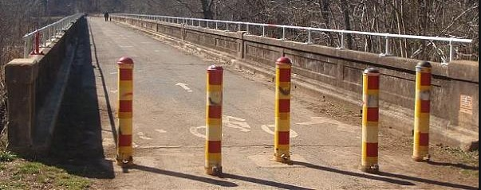
Old Bynum Bridge (12)

POKEBERRY CREEK BRIDGE
Pokeberry Creek flows into the Haw River below Bynum. US 15-501 now crosses it on the two boulevard bridges just south of Mount Carmel Church Road. I remember it from 70 years ago as a small, easily forded, creek crossing an abandoned road. It froze one cold winter, and we went ‘skating’ on it. There is an old Southern expression, ‘See you tomorrow the Lord willing and the creek don’t rise.’
Early wooden bridges were built across Pokeberry Creek, but the history is unclear. In 1895, the County commissioners paid $5 for “work on Pokeberry bridge” (13). In 1904, they paid $22 for “building bridge across Pokeberry Creek” (14). Then, a request was submitted in 1912 “to build a bridge across Poke Berry Creek on Chapel Hill Road about 2-1/2 miles east of Bynum near Jones Grove. This has been a troublesome and dangerous ford for many years and frequently gets past fording during heavy rains and we believe it would be in the best interest of the nearby citizens and the traveling public to have this creek bridged. It is also a part of the RFD route from Bynum” (15).
The creek was finally bridged by a concrete bridge that still stands east of the boulevard bridges. The brass plate has been stolen, but I assume it was built around the same time as the 1922 concrete Bynum Bridge because the concrete side-walls have the same pattern. It is still open to local traffic on Karen Calhoun Road.
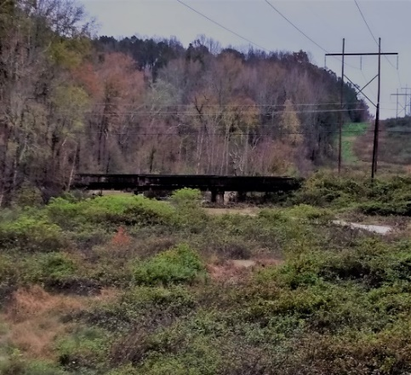
Old bridge over Pokeberry Creek as seen from US 15-501

It is a sturdy bridge that withstood early challenge. “SEVERE CLOUD BURSTS IN CHATHAM COUNTY, Rockingham, August 3, 1924. Travelers coming here tonight from Pittsboro report a severe cloudburst in Northwestern Chatham County early Sunday morning. Haw River at Bynum rose to within four feet of the high water mark made in the freshet of 1908. Pokeberry Creek rose over the concrete highway bridge and the fills were badly washed. (16)

MORRIS ROAD CULVERT
Morris Road runs west from the entrance to Fearrington Village, past the fire station, and after a mile crosses Pokeberry Creek. Or, at least it did. Hurricane Florence overwhelmed two large culverts and destroyed the road. How can that happen? The sketch shows why.
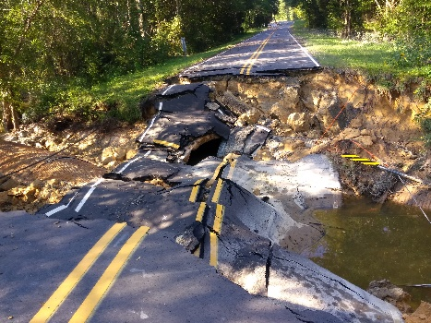
Morris Road September ‎22, ‎2018

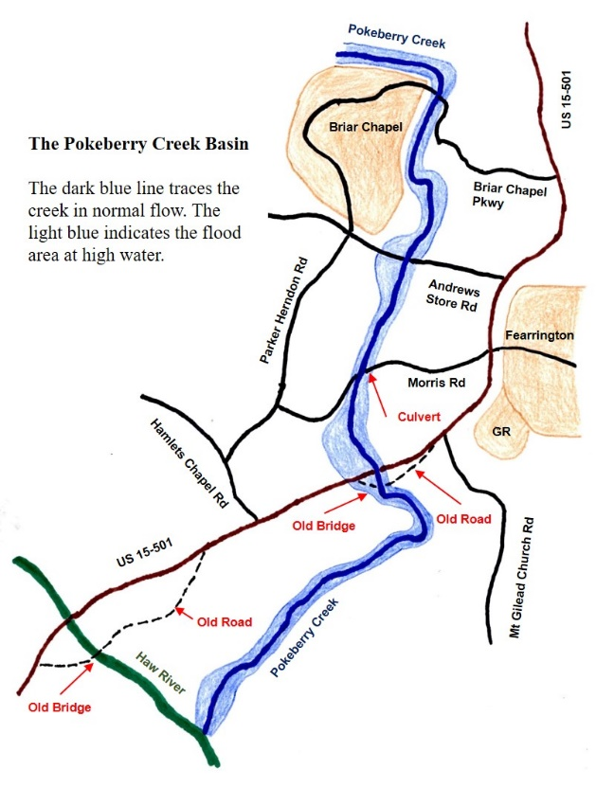

Pokeberry Creek originates above Briar Chapel and is fed by many smaller creeks. Above Morris Road it passes through steep valleys. These cause rain on the hills to flow down into Pokeberry which makes its water rise quickly and flow faster. The water accelerates as it runs down the middle of the sketch and creates enough force to destroy the culverts under Morris Road. In the flatlands of Eastern North Carolina, floodwaters rise slowly, but this situation is more similar to flash floods in canyons out West.
Between 1946 and 1954, I rode the school bus to school in Pittsboro. The route came down the hill from Mann’s Chapel Road, past the Fearrington farm, and across the old Pokeberry bridge. It then went up the hill, past Hamlet’s Chapel Road, turned to go down through Bynum and across the Haw River bridge. The bus groaned up the steep hill back to what is now the Boulevard. See the route over the two old bridges on the sketch.
Buses were driven by high school boys and girls; only a driver’s license was required. My older brother David drove me at first. It was exciting as a seven-year-old to have a big yellow school bus parked in front of the barn. It was even more exciting one morning as we started up a hill on muddy Mann’s Chapel road to pick up the first student. The bus gradually slowed to a stop and started sliding back down into a ditch. And, I missed a whole day of school.
REFERENCES
(1) https://dc.lib.unc.edu/cdm/singleitem/collection/ncmaps/id/937/rec/3
(2) http://dc.lib.unc.edu/cdm/singleitem/collection/ncmaps/id/950/rec/1
(3) London, John Haughton, “Since Then – A Short Illustrated History of Pittsboro”, 1986, pg. 9
(4) http://dc.lib.unc.edu/cdm/singleitem/collection/ncmaps/id/2064/rec/6
(5) Cassebaum, Anne Melyn, “Down Along the Haw”, McFarland & Company, 2011, pg. 154
(6) Hadley, Horton, Strowd, “Chatham County 1771-1917”, pg. 406
(7) Cassebaum, ibid, pg. 153
(8) Chatham Record, October 3, 1878
(9) Hadley, ibid, pg. 53
(10) ‘Covered bridge at Bynum’, State Archives of North Carolina
(11) Hadley, ibid, pg. 190
(12) ‘Images for Old Bynum Bridge’ Wikipedia
(13) Chatham Record, May 9, 1895
(14) Chatham Record, April 7, 1904
(15) S. E. Dunaway, “Chatham County N.C. Road and Bridge Records, Vol. 2”, 2014, pg. 54.
(16) Roxboro Courier, August 6, 1924

